Project Design Phase
Solution Architecture

Date | 15 February 2025
Team ID | LTVIP2026TMIDS66355
Project Name | Laptop Request Catalog Item
Maximum Marks | 4 Marks

Solution Architecture – Laptop Request Catalog Item:
Solution architecture for a Laptop Request Catalog Item connects employee laptop request needs with the right technology solutions. Its main goals are to:
● Identify the best technical solution to efficiently request, approve, and allocate laptops within the organization.
● Describe the system structure, request workflow, features, and performance clearly to stakeholders.
● Define laptop request functionalities, approval stages, and system requirements.
● Provide clear specifications for designing, implementing, managing, and delivering the laptop request solution effectively.
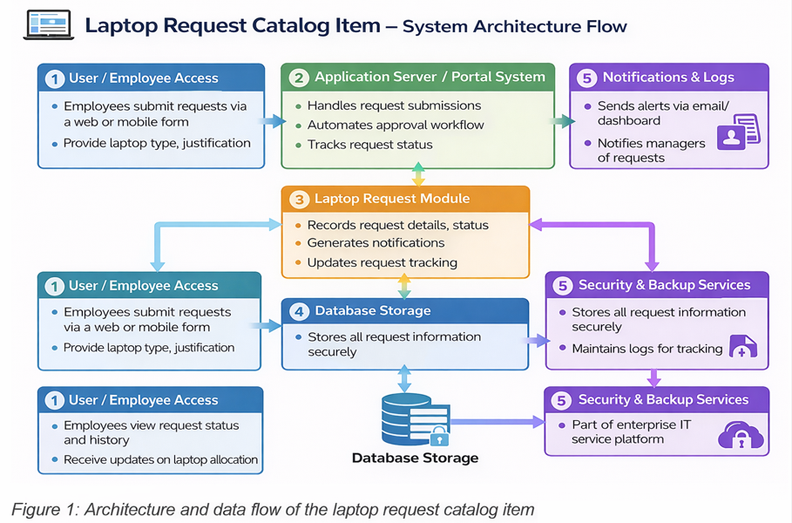
Example - Solution Architecture Diagram:

Reference: https://aws.amazon.com/blogs/industries/voice-applications-in-clinical-research-powered-by-ai-on-aws-part-1-architecture-and-design-considerations/

